When trying to add parts for competitor equipment (like AMW, Grindmaster, Fetco, Curtis, etc.)
- You add a part
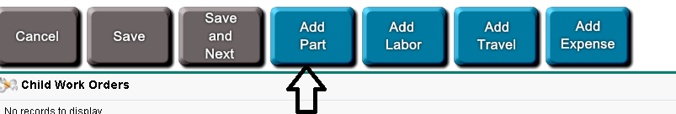

- Next you click the magnifying glass next you where you would enter a part number
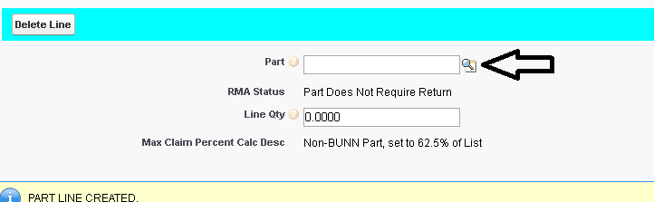
- When the window opens you go to the “Filter By” section
  - In the first drop down you change it to “Manufacture P/N”
  - The next drop down you change it to “Starts With”
  - In the section after that you will put the competitor part number
  - Then hit “GO!”
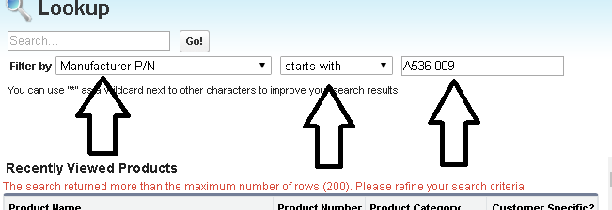

- Click on the product name and your part will be added
